Shopee E-commerce System Development
Database Design

Group 4:
- Azzahra Puteri Kamilah
- Marsha Aulia Rizky
- Marchella Keira Sambuaga
- Fatwa Putri Jingga
- Syakira Lathifa Awliya

Entity Relational Diagram (ERD)
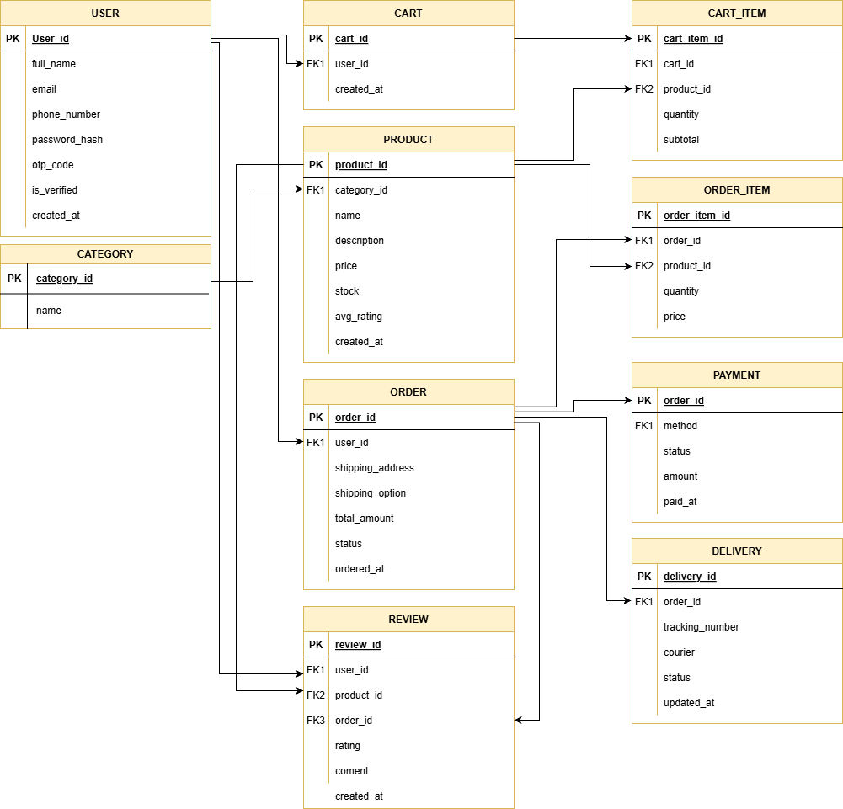
C. Cardinalities
1) USER - CART 1 : N
- One user can have many carts
- One cart belongs to only one user
2) USER - ORDER 1 : N
- One user can place many orders
- One order belongs to only one user
3) USER - REVIEW 1 : N
- One user can write many reviews
- One review belongs to only one user
4) CATEGORY - PRODUCT 1 : N
- One category can have many products
- One product belongs to only one category
5) CART - CART_ITEM 1 : N
- One cart can contain many cart items
- One cart item belongs to only one cart
6) PRODUCT - CART_ITEM 1 : N
- One product can be added to many cart items
- One cart item refers to only one product
7) ORDER - ORDER_ITEM 1 : N
- One order can contain many order items
- One order item belongs to only one order
8) PRODUCT - ORDER_ITEM 1 : N
- One product can be in many order items
- One order item refers to only one product
9) ORDER - PAYMENT 1 : 1
- One order has only one payment
- One payment belongs to only one order
10) ORDER - DELIVERY 1 : 1
- One order has only one delivery
- One delivery belongs to only one order
11) ORDER - REVIEW 1 : N
- One order can have many reviews
- One review belongs to only one order

12) PRODUCT - REVIEW 1 : N
- One product can receive many reviews
- One review refers to only one product
Data Flow Diagram (for each activity/feature)
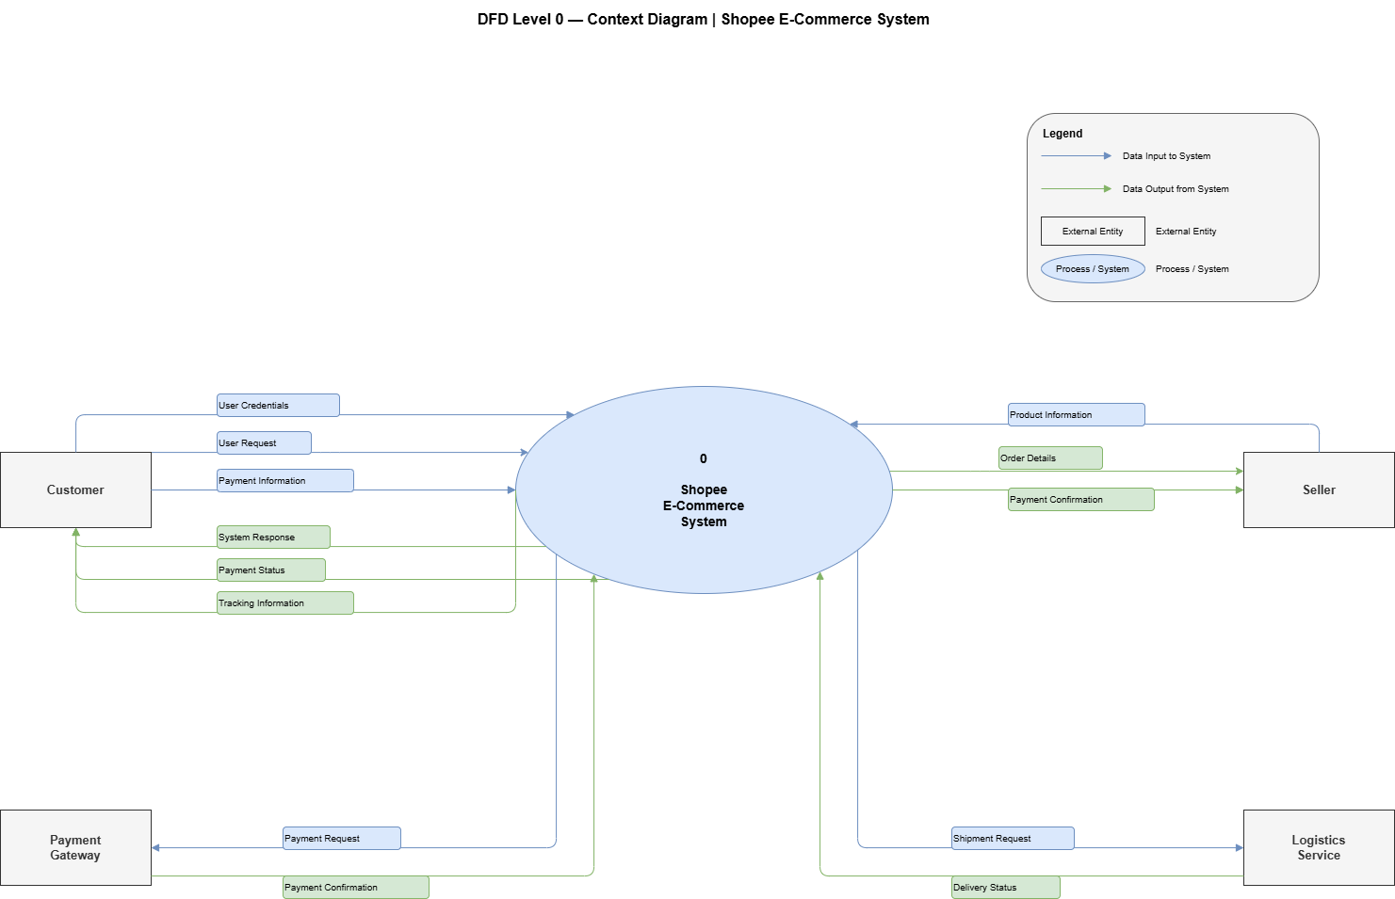
- DFD Level 0 (Context Diagram)



- DFD Level 1
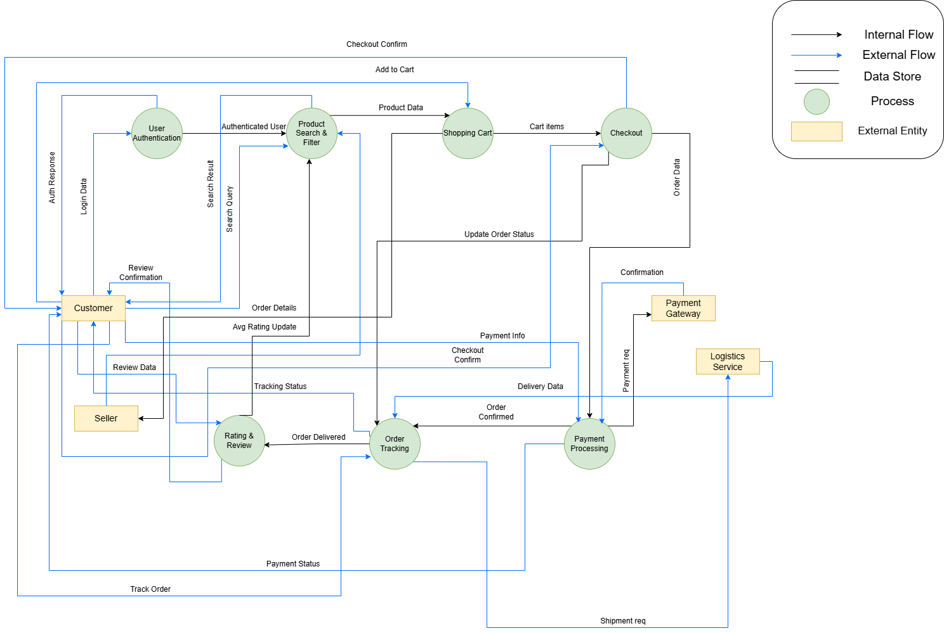
- DFD Level 2
